Kyrgyzstan
Bishkek Telephone: +996705525856
11-mcrn Email: bakyt1958@mail.ru
17a/40 (Mr)Bakyt Kadyrshaev
And his son Malik Kadyrshaev

February 14, 2010

I appreciate you for your interest in our mining sector. I am very glad and grateful for you of your readiness to help me. Particularly even I am surprised, that it can be. Also I am very glad for my son, who knows English and French.
Firstly, I appreciate the Canada’s level of development in the mining industry. Our country -Kyrgyzstan which is situated in Central Asia, in comparison with Canada absolutely small and some times more low on a level of development in mining business. We should have to learn from Canada in development of technology, techniques and mining management. After lots field works in the field of geological prospecting and mining operations, I had an idea to create private business in mining with attraction of investments. But attempts did not bring success in the absence of means and reliable partners.
The idea was simple enough – to create a firm in drilling business and rendering of services in prospecting process for the companies which in our territory conduct works. Before world crisis the drilling volume could reach at us to 12 000 running meter and more in a current of year only for one company. It becomes actual that chisel works for water (exploring for mineral water) and other branches of a national economy, the techniques and technologies in mining practically exist from the USSR period, except some companies. The Chinese techniques and equipments are starting to dominate in the market, but without technologies where its real application taking into account specificity is excluded.
It would be final more interestingly from the Canadian friends to represent and advance their ideas and business in mining, both in territory of Kyrgyzstan, and in the whole Central Asia. If you will have desires and intentions we are ready to co-operate in a private order for advancement and partnership or representation Canadian business in Central Asian region. A spectrum of service in mountain techniques and technologies, beginning from searches, investigation and mining operations and for other scopes, it is wide enough and interconnected with development of requirement of economy of China. If there will be any questions, I am ready to answer.

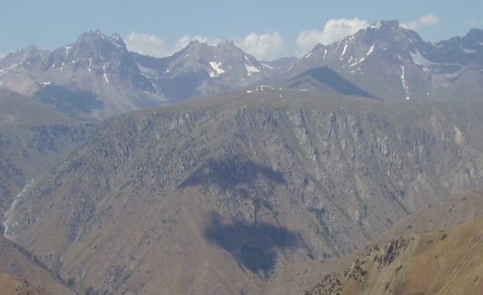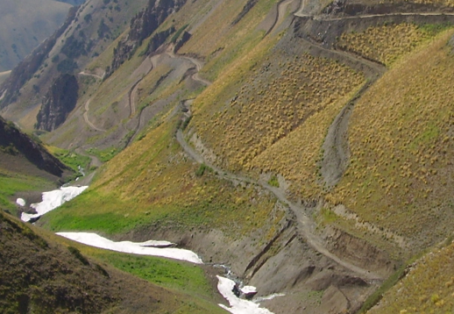

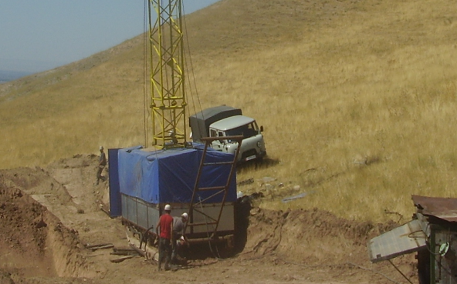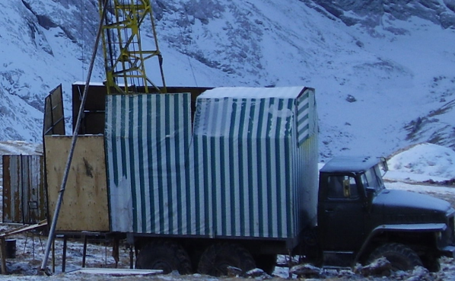

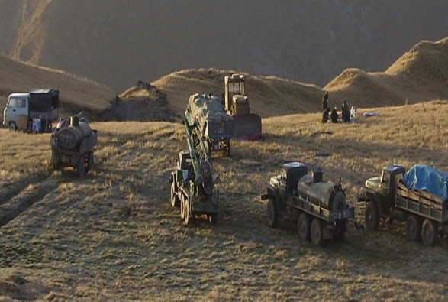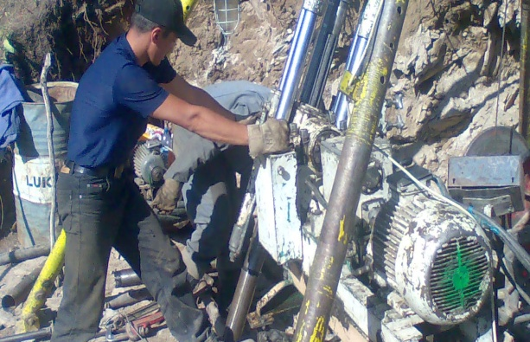

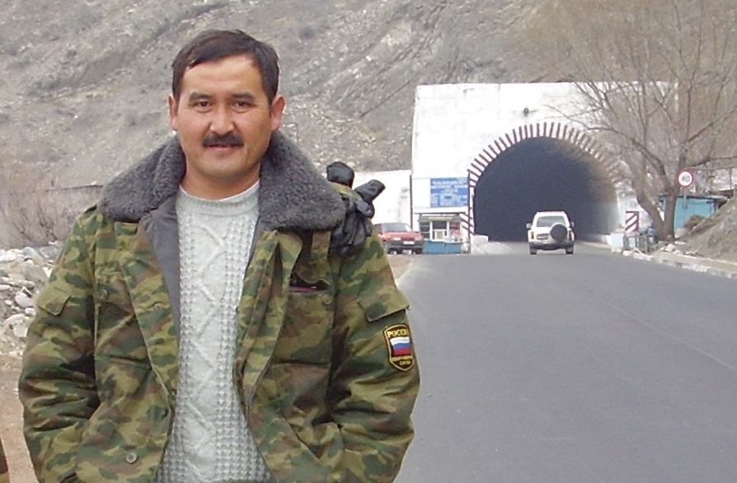
About myself: Kadyrshaev Bakyt, was born in 1958, the mountain engineer and a geologist, worked in the extracting companies for gold and copper, and also in prospecting drilling. I live in Kyrgyzstan, Bishkek. At present time I engaged in local projects in mining business for the separate companies. I have a desire to co-operate and work with more modern techniques, technology and idea, as in territory of Kyrgyzstan, and as a whole in the Central Asia.

